Lock manual
RF proximity card lock series
Software Version V8
Chapter
1, intelligent locks Introduction
The company's Smart Card Lock with stable performance and superior functionality as a smart card door key, door locks microcomputer intelligent control, is a safe, reliable, efficient energy-saving, technologically advanced, flexible operation, convenient, easy to manage multi-functional intelligent lock. Broad scope of application can be used for hotels, guesthouses, organs and departments, modern offices, office, residential and so on.
Second, the main features of intelligent locks
Induction Card Series Intelligent lock as an independent intelligent door locks, by the smart card, smart door locks, card machines, management software.
A. Without external lines, without a computer network, installation is simple and convenient.
B. Various types of door lock inside the micro-computer can be intelligent, smart card identification and processing, complete the corresponding work.
C. Lock microcomputer can store 880 times the recent door locks records, and can be extracted at any time by acquisition instrument records the lock open.
D. Intelligent lock cylinder using the international standard five-latch structure, safe and reliable.
E. Low power consumption, quiescent current is negligible. As a result of a unique low-power technology, this series of lock used in all four Day 5 Battery power supply, the normal use of the circumstances under which more than one year continuous work.
F. Intelligent Alarm function: When the user did not properly closed the door, or a deliberate attempt to skew the tongue stick to the combination of locks, door locks will be issued by sound, light alerts to remind users to shut the door.
G. Smart locks can choose to set to normally open (channel) state, to facilitate meetings, rallies purposes.
H. Advanced system backup program: Smart lock can be in the system hardware and software can not be issuing, through a specific function card to create a temporary guest card, so as to avoid inconvenience to customers and management confusion.
I. Wide range of applications: can be installed in the door thickness ≥ 35mm wood door or metal door.
3, intelligent locks parameter index (see Table -1)
Lock Type  Means S | Induction Card Smart Lock
Power Supply | DC4.5V-6.5V, 4 Jie 1.5V AA alkaline batteries;
Quiescent Current | "18 mA ;
Dynamic Current | "200 milliamperes ;
Storage temperature | -20 ~ +85 ℃;
Storage humidity | 10 ~ 98% RH;
Temperature | 0 ~ +80 ℃;
Humidity | 15 ~ 95% RH;
Cards close to detection method | RF pulse reflection near the detection;
Infrared pulse emission frequency of | 4 Hz ;
Induction frequency | 100 K-150 K Hz ; Is normally 125K
Open method | With the door card insert (collision) card once issued a "tick" heard, green light, you can open the door handle turning;
Opening hours | After turning knob lock will automatically lock, if the plug (collision) card does not open the door locks automatically lock within 5 seconds;
Undervoltage Tips | When working voltage below 4.8 volts, open the door when the red light, buzzer alarm, this time can also be reliable and open the door 250 times;

Chapter Installation
A smart door lock installation instructions
1, excavation lock slot:
(1) the appropriate height on the door before opening cylinder tank: on the door side of the Central Office, digging cylinder tank (see Figure -1); dug, the door openings and outside in order to provide our template (see Figure -2, Figure -3) for the kind of hole, first one side of the door opening half (dug cylinder tank Office), and then at the other side of the hole opened, this operation can avoid the error;
Note: the door side of the middle office, first dug 24 mm X 160 mm, depth 110 mm of the cylinder slot, dug, the same side of the door to cylinder groove center axis symmetry, dug a 30 mm X 206 mm, a shallow groove depth 6 mm. (Light tank role is a fixed cylinder and the installation side of plaque) Opening the door side of the template should be posted flat vertical plane, the template level in large-scale lines the upper part of the tongue oblique plane, the template side of the scale line flush door.
Cylinder tank plan L819/820/821/L827 series of European style lock template plan (Figure 1, 2) (Part Name Table -2) 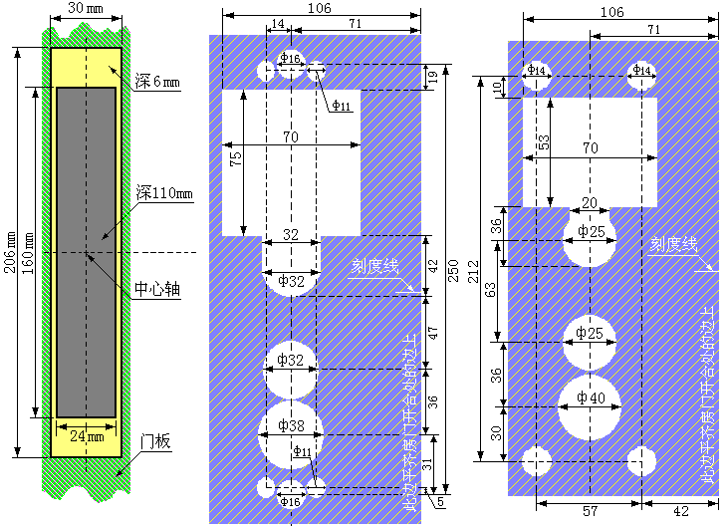
2, the installation lock: L815/817 series of rectangular lock template plan
L815 Series Intelligent Lock major component parts and the installation process in Figure 1, 3, 4 below; Please refer to the numerical order (Part Name Table -2) to install locks. 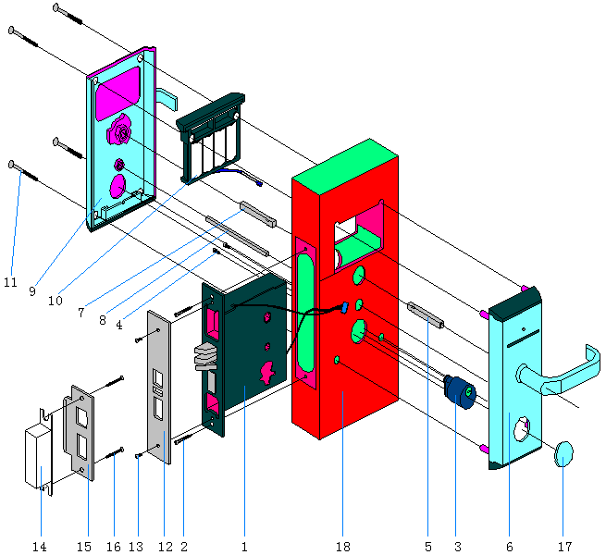
Figure -4
1 | Cylinder (lock body) | 10 | Battery Box
2 | Cross-slot wood screws | 11 | Hexagon screw
3 | Mechanical lock | 12 | Side trim
4 | Hexagon screw (lock) | 13 | Cross slot countersunk head screws
5 | Generous axis | 14 | Pinch plastic box
6 | Front | 15 | Lock plate
7 | Generous axis | 16 | Cross-slot wood screws
8 | Rectangular axis | 17 | Lock cranial
9 | Rear Panel | 18 | Door

Table -2
Software installation and use of
First, an overview of
Lock the basic settings:
Door locks installed, BAN, floor, room number increase is completed, put into use before the use of locks to install the card on the system settings. _{Setup process is as follows:}
1, set the lock with the installation of card number; point "action" sub-menu "lock the room number is set" every room should be a one-card system, an installation to install locks numbers.
2, with the clock card to set the time lock. Only one can be as much as possible within 10 minutes to lock on the credit card to reduce the lock time and computer time gap.
Note: The card is not installed locks on the system information has been set, in order to re-set the lock, first remove the lock with the clear card information.
Card use and management:
-  Emergency door cards: You can open all doors, including those locked inside. After use, lock the state is always open. Generally do not have this card, only in exceptional circumstances only use this card.
-  Total control door cards: You can open all locks, even if you can open the door to shut. Generally by the hotel's General Manager, Rooms Division Manager and other management personnel hold a total card loss reporting capabilities, in case of loss, report the loss function should be a total replacement card and use it to open all the locks again, so that the original total card door function will fail, and if recovery had been reported loss in the overall function of card in your system to re-open the door to do a general card.
-  BAN door card: to open all the doors of a one floor, and can not open the door to shut. Such as: Hotel *** \ *** Building. Room management personnel generally held.
-  Floor door card: to open an area of a floor of a one all the doors. Such as: ** Hotel \ ** Building \ ** floor.
-  Access door card: to open the specified door, with alternating open function (one touch open, taking even one off), are generally used for conference rooms or other special occasions.
-  Clock card: used to calibrate and set the internal clock for each room door.
-  Clear Card: remove lock information, so that locks back to the initial state.
-  Blockade card: do not have the room for the closed room during the blockade, in addition to all but emergency card can not open the door.
-  Unlock the card: Card is used to unblock blocked the door.
-  Check out part-time set up card: used to limit the guest check-out time cards. If set to 12: 00, then after midnight, the guests can not open the door card. This card is only for the hotel check-out within the set time of a unified, generally can not be used for any reason, terminate the guest card away door feature, so operation will directly affect the follow-up check-out when the customer opens the door card door problem, After using this card set is usually a fixed function. To return to the pre-set to be re-set the card is set to write part-time before check-out.
Note:
  - 1, If you lose the card issued, it should report the loss of the same type issued a card, and use this card to open it once all the locks on the doors to the previous report of loss of effective cards.
  - 2 In the course of Always back up your data, database corruption, you can use this backup and recovery.
System Registration
【Function Description】:
System administrator for the Admin default password is 12345. (Into the system immediately after you add a new administrator to ensure system security.)
【Operation】:
  - The first log management system will empower the code input, at the same time placed on the reader authorization cards, such as No authorization code or license key has expired, optional on the "Register later" option in order to obtain the correct and effective through the yards of the registration yards.
  - Press OK button to start to register and to initialize the software locks, this time the system will automatically find the available communications port, users do not have to select communication port number to complete the communication with the reader. If you choose to register After entry, press OK to read after the authorization card authorization information to the system database, after the success of the system will automatically exit, the user need to re-run the system, re-run the system will display the registration code based on the information window.
Staff management and authorization
【Operation】:
A. Open the "System" click on the File menu in the "Operator Settings" sub-menu, then the employee information set the pop-up window.
B. the addition of new employees, employee information to set the box click the Add button, then enter the new employee in the name of column name and login password, department, level. Click "Add" button. (Note: the increase in the first new employee for the new system administrator.)
C. If you want to modify an employee's information, select the employees, the revised data points, "Modify" button.
D. If you want to delete an employee information, select the employee click on "Delete" option.
E. Staff permission settings, select the operator required to access the menu and functions of authority can tick the box. In order to facilitate the management and safety, please carefully select the staff permission.
Backup
【Function】: Data backup is mainly used for the entire database, data, backup to the backup file, the file name format: Db date when the minutes and seconds. Dbk;
【Operation】:
- From the "System" menu, click "Database Maintenance" sub-menu, the system pop-up dialog box.
- Click "Backup", the system will automatically save the backup file to the default path.
- Backup data path can also be optional.
To restore a backup
【Function】: computer failure, or reload the software to recover data after re-setting information without right door does not affect the normal use of locks.
【Operation】:
- From the "Database Maintenance" menu, click "restore."
- Select the desired data recovery (operation log, the system card records and occupancy records) and date.
- Click "OK" button.
BAN floor parameter setting
【Function】: used to add, delete, modify the BAN information;
【Operation】:
- From the "System" menu, click "System Parameters" submenu.
- Click the "Add" button, enter the name BAN, BAN names and the corresponding Notes, and then click "Add", you can save your settings;
- If you want to modify a BAN information, click the BAN you want to modify, then click "edit" button to modify the corresponding information, finally click on "Modify" button. .
- If you want to delete a BAN information, click the BAN you want to delete after, then click the "Delete" button, the system pops up the following diagram dialog, click "Yes", you can put the BAN deleted.
Room Number Set
【Function】: mainly used to add, delete, modify room information. Set room type, maximum number of system cards.
【Operation】:
- From the "System" menu, click "System Parameters" sub-menu - room number is set
- Click the "Add" button, select the BAN,, floor, room number, name (ie room number) room type, card number and the corresponding Notes, and then click "Add", you can save your settings.
- If you want to modify a particular room information, click the room you want to modify, then click "edit" button to modify the corresponding information, finally click "edit" you can save your settings.
- If you want to delete a room information, then click the room you want to remove, after re-point "delete" button, Select "Yes" button.
- If you want to delete all guest rooms information, then click on "delete all" button, click "Yes", you can put all guest rooms removed.
1. Operation
Issue open room card
【Function】: Guests for data entry of information and production of the corresponding occupancy guests cards.
【Operation】:
- Click the second row made guest card icon or from the "Actions" menu, click "issued guest cards" submenu.
- In the "check-in" window, respectively, guests enter the name, ID number, pre-live days, choose the room category, and in the left side of the room list, select the arrival room, and then click the "card" button, the system began to stay in the guest information Write smart card, the system is suggesting that the room makes a successful guest card information prompt box, click OK to complete the operation of the guests stay.
- Check the number of days can only be accurate to the maximum 63 days, greater than 63 days can only be in months as a unit, the biggest month for 15 months, more than 15 months can only be in units of years.
Guests continued to live to write cards
【Function】: Modify the guests stay at a valid time.
【Operation】:
- From the "Actions" menu, click "guests continued to live to write cards" submenu.
- To the guests of the guests card on the card device, and then click the "reader" button, read out the guest stay information can be changed, "continued to live a few days" to change from the time of the pre-revised after click on "continue to live" button to write the guest card information.
Check-out Operation
【Function】: for handling guest check-out, recycling guest card, empty guest card information.
【Operation】:
- From the "Actions" menu, click "guest card check-out" sub-menu, the system pops up the following interface.
- The guests on the guest card issuing device, select the guests stay in rooms, and then click the "reader" button, and then click the "check out" button, first check the system for dealing with the guests, and then empty the guest card .
- If the card is lost, can be no card check-out.
Distribution Management Card:
【Function】: mainly for the production of the clock cards, clear cards, emergency cards, Master Control Card, floor cards, access cards and other special features of the management card.
【Operation】: From the "Actions" menu, click "lock the room number is set" "Issue Management Card" sub-menu.
System, installation of card:
  - Installation of card, the room number information is written to this card, through this card will be entered into the lock on the room number.
  - Clock card, the computer time to write to this card, by the time this card will be entered into the lock on the computer.
Emergency Card: You can open all locks, including those locked inside. Brush once a lock, painted a closed lock.
  - Master Control Card: You can open all locks, including those locked inside.
  - Floor Card: can be opened to the corresponding floor, can not open the door to shut.
Cancellation of the card features
【Function】: recycling a variety of management card and clear the corresponding information on the card.
【Operation】:
A. From the "Actions" menu, click "cancel the card function" submenu.
B. To recover a smart card on the card-issuing machine, then run the "Reader" button to confirm and click "log off" button, the system immediately recovered the card and to clear the original information for this card, recovery after the success of the success of the dialog box prompts.
System Card report the loss
【Function】: report the loss of the missing cards, to prohibit the use of the card.
【Operation】:
A. From the "Actions" menu, click "System Card report the loss of" sub-menu.
B. Pull the scroll bar to find the appropriate card category, BAN number, floor number, room number, cardholder, card number, and then click to select, then click the "report of loss" button, loss reporting system card after the success of the success of the dialog box prompts.
- Report the loss by making a good lock on the card in the corresponding credit card, or complete the report the loss. Master Control Card or floors cards report the loss to Ze Xu loss report card to all of the locks on the brush once, floors cards should be to the appropriate locks on the floor of the brush all the time.

Read the open records
To see a door open record, click on "Actions", "read the open record."
Which devices typically choose "collection instrument (LC-HI008)", the first instrument with the acquisition of the need to view the records collected before lock records, and then in conjunction with the PC-up, click on "Read" button, to display all the information.

Lock the room number is set (system installation card)
System, installation of card locks are fitted well, the need to make every room of the installation of card, in accordance with the room number to set the order of installation. Then issuing a clock card, preferably within five minutes, touch the door all the time, the lock time to check the internal accuracy. After a period of time lock system time clock time may be inconsistent, the door would not open. Therefore, regularly check the time with the clock card.
Note: The card is not installed locks on the system information has been set, to reset, first remove the lock with the clear card information.

Management Preferences
Select the menu "Action" - "" management parameter settings ", select the lock-related parameters, select the type issued by the management card, click on" Save "to complete the parameter setting operation.
● Precise positioning Card ID: refers to the reader when the computer automatically searches for the card ID, the card system will directly affect the speed, generally do not select this option, except in the system before considering the need to protect is enabled.
● By default, when a new issue opened the door card door against the old door card access: the issuance of new door card, the old door card automatically lapse.
● Check back when you need more cards to make: that double, triple, made a two or three cards, and check-out must be all of the cards back, and it can be displayed without a card room.
● Thematic framework of the style: The main interface of two different styles. (In the entry-operation with description)
(B), the query
Query system card records
【Function】: All cards are recorded production, through which the module can query the system card records.
【Operation】: From the "query and report form" menu, click "system card records" submenu.
If you need to print, you can click on the "Print" button, the data printing.
Record card
【Function】: card report module main function is to statistics of the current holder of the card holder details, for managers to follow.
【Operation】:
- From the "Search" menu, click "Report Card" sub-menu, the system pops up the following interface.
- Click "Print" button, you can print out the information to cardholders.
Logging Operation
【Function】: statistical operator sign in and out of the system as well as a variety of important operational details.
【Operation】: from the "Search" menu, click "Action Log" sub-menu, the system pops up the following interface.
(C), tools
Modify the state: If there is room to write card check-out is still a key icon can not be changed, click the Edit Room-state status will be changed to an empty room can be a net room
Notepad
【Function】: Notepad main function is to call the operating system, the Notepad program for operators transcripts;
【Operation】: From the Accessibility menu, click Notepad book menu system is a matter of the program pop-up into account. For operator use;
Calculator
【Function】: Calculate the main function is to call the operating system's calculator program for calculation for the operator;
【Operation】: From the Accessibility menu, click calculator sub-menu, the system pop-up calculator program. For operator use;
(E) to help
Help topic: Where can click into the ambiguity in help topic for more Xiangxi's instructions.
Regarding
Install locks should be noted that matters:
Check circuit board hole hole location is suitable, and confirmed that no wood and wood stand up circuit board, installing locks must use genuine 5 alkaline batteries, locks installed after checking whether the horizontal and vertical lock, handle and the locking knob is smooth, with the debug card (authorization card) is able to properly open the door, installed a computer system to ensure that the USB host computer serial port can be used normally.
Basic knowledge of the use of smart locks:
Each hotel will complete an authorization card (ie Client Card) This card is equivalent to the hotel's identity code, is also a unique code, install software code will be read into the system, if the authorization card loss will seriously affect the hotel management, please contact The company or a local dealer, to install the software required to enter the license code can be used normally. If the card reader failure may have a computer USB port with dust or their connections, or damage to the chip card, please check the connected serial port and restart the computer or for-cards tested.
Intelligent lock malfunction and exclusion methods:
I. Guest Card, Floor Card can not open the door, with a total card can open the door
Failure Analysis: ● Cylinder generous tongue switch chip off (5 tongue lock)
    - Door closed when the tailgate is not a good loaded ramp tongue in which a circuit board is not fully Red light alarm
    - Room Number information chaos
Solution: ● replace the motor line
● reload a good tailgate (that is, oblique plaque), and re-set the lock room number information
Second, the guests card can not open the door, floor card, the total card can open the door
Failure Analysis: ● Lock information is set incorrectly (ie, room number information on installation error), guest numbers do not match with the room number
    - Lock time and computer time settings are not synchronized
Solution: ● re-set the lock room number information
    - Re-calibration system, a clock card time (for each school when the new system within 15 minutes of card is best to lock the door brushes)
3, the guest card, Floor card, the total card can not open the door and the red light
Failure Analysis: ● Lock information not set, door locks in a factory state
    - Lack of battery power
    - Lock Information Garbled
Solution: ● replace the battery
● re-set the room number information
4, the guest card, Floor card, touch the card a total card no response, light does not shine.
Failure Analysis: ● Lock did not install the battery or the battery positive and negative Misplaced
    - Electrical wire circuit
    - Circuit board is not power
Solution: ● to lock installed a new battery or check the battery positive and negative is correctly installed
    - Interface to access good
    - Replacement of the circuit board
5, door locks appeared normal open state
Failure Analysis: ● Lock factory set to normally open state
● door motors did not touch the card back to bit a power outage
    - Pieces of broken free
Solution: ● use debug card to open the door so that the door lock switch back to normal state
● Check the power is normal
    - Free Replacement Parts
6, touch the card to normal, but can not open the door, idling
Failure Analysis: ● Door-hole is not a good start, door locks installation panel or handle side-axis is not horizontal and vertical installation
    - Cylinder of free pieces of round arrows do not target the cylinder lid arrows
Solution: ● re-fix the door lock hole in place
● free pieces of round the cylinder alignment cylinder lid arrows
7, reader error, on-line error
Failure Analysis: ● system card machine socket is not connected and
    - Is not installed on the system card machine driver
Solution: ● Check the system card machine jack, reconnect the system of card readers
● re-install the system Kaka drive
8, door locks power -
Failure Analysis: ● battery quality problems or the battery box, power line interface wet oxidation.
● Lock tailgate closed is not a good loaded circuit board after the red light and alarm sound
Solution: ● replace the battery, battery box or electrical line (if necessary, to replace the circuit board)
    - Reload a good tailgate (that is, oblique plaque)
九. Credit card only when the power of the voice, look at the green light flash.
Failure Analysis: ● the battery is installed against the negative
● the battery quality problems
Solution: ● remove the lock to re-install a good battery
● replace the battery and check the availability of loose wiring port

